Appendix A
Figure 1. Wally and the Major
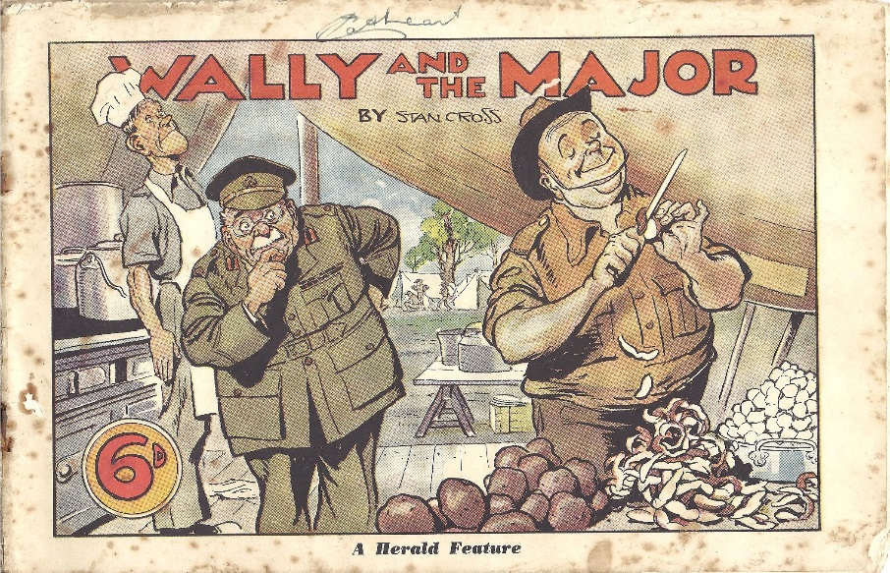
Figure 2. Bluey and Curley
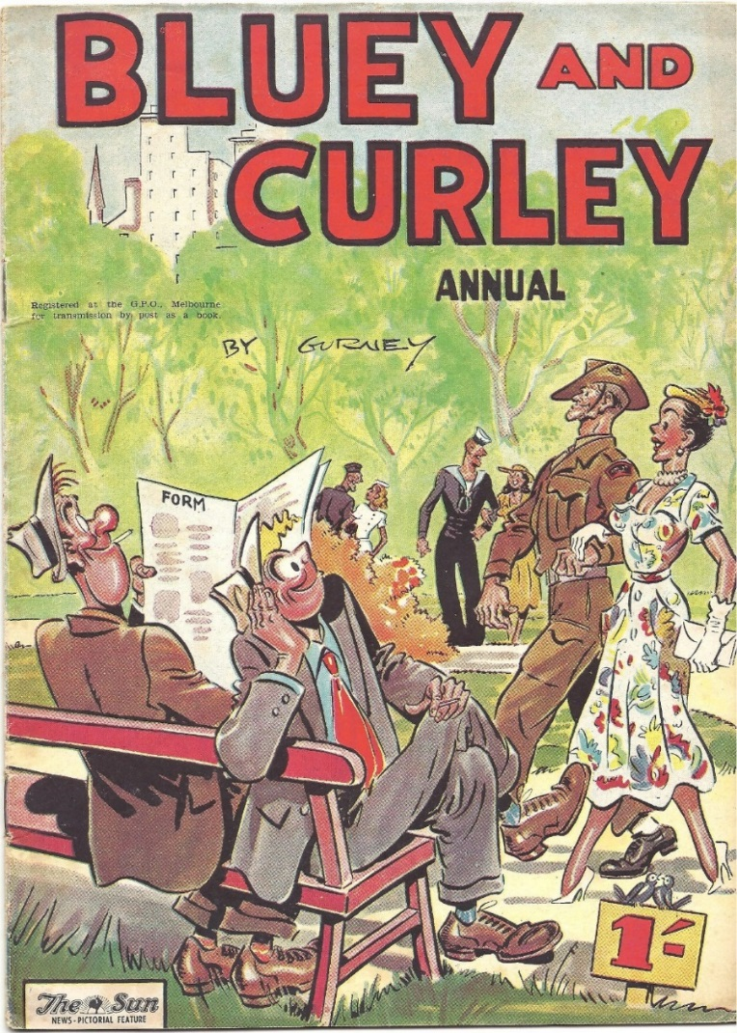

Figure 3. Wanda the War Girl
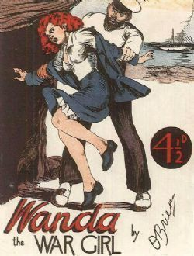
Figure 4. Commando: Jap Killer!
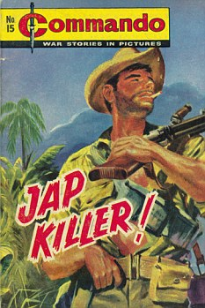
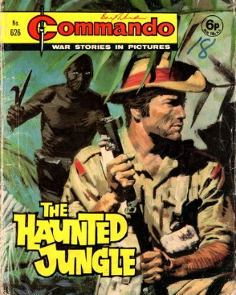
Figure 5. Commando: The Haunted Jungle

Figure 6. Commando: They Called Him Coward!
